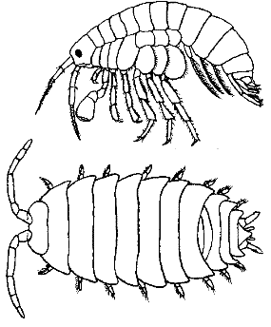**Isopod Behavior, or The RollyPolly Lab**

**Objectives:**

* Observe various aspects of a terrestrial isopod
* Conduct experiments examining the responses of isopods to various environmental factors
* Design and conduct an investigation of animal behavior

**Isopod Handling and Rearing**

Raise isopods in a clear shoebox or similar, the bottom should be covered with soil or sand and kept moist (use a mister). An old piece of bark, and leaf litter covering the soil. Isopods can be fed carrots, raw pototoes or apples (alternately fish flakes can be used as food). Moldy food or soil should be removed. Females can carry up to 200 eggs in a brood pouch underneath her abdomen and will remain in the pouch for about three weeks - they look the same as adults, only smaller.

Larger isopods can be handled and observed easily with your hand, by picking them up with your fingers or gently scooping them up with a spoon. They are fast walkers and can withstand short drops. Immature isopods are more fragile than adults.

**Isopods are also called sowbugs and pillbugs.

**Background Information**

Terrestrial ispods are land dwelling crustaceans, commonly known as sowbugs or pillbugs (or rollypollys). They are related to lobsters, crabs, and shrimp and terrestrial isopods breath with gills. While they look similar, sow bugs are different from pill bugs. Pill bugs will curl into a ball when threatened whereas sow bugs will attempt to flee. Since your isopods are caught from the wild, make sure you are using the same type for your experiments.

**Ethology** is the study of animal behavior. Many behaviors involve movement of the animal within its environment. In this exercise, you will investigate some innate (instincts) behaviors of isopods.

Orientation is a process by which animals position themselves with respect to spatial features of their environments. **Taxis** involves the turning of an animal's body relative to a stimulus - either toward or away. **Kinesis** is a random movement of an animal in relation to a stimulus, like cockroaches scattering when the light is turned on.

Consider the following example: A researcher places a dead rotting mouse in the center of a test area and adds a carrion beetle (an insect that eats dead animals) somewhere on the surface. The beetle crawls forward for three seconds, turns and crawls in a different direction for three seconds, and so on. The researcher concludes that the beeetle is moving randomly in relation to the dead mouse. Continued observation reveals that the beetle crawls faster (and covers more ground) when it happens to turn in the direction of the dead mouse. In addition, the beetle crawls more slowly (and covers less ground) when it happens to crawl away from the mouse. In this way, the beetle's random movements will eventually bring it to the dead mouse. It is important to take in details such as time spent crawling in one direction or another when observing the movements of the animals.

**Part A - Isopod Observations**

In the first part of this exercise, you will observe isopods (pillbugs) and record what you see in the data section of your lab report.

Analysis **(include in lab report)** - some answers you may need to investigate on your own

* How do the pillbugs seem to sense their environment?
* Are they all the same species?
* Can you tell the difference in males and females?
* How many eyes do they have? How many legs?
* Do they exhibit dominance behaviors?
* How do they respire?
* What are some stimuli they seem to respond to?

**Scientific Sketching**

When you make a good sketch of an isopid, don’t just draw an oval with a few squiggly legs; you are expected to do a scientific illustration that includes the following:

* + Relative proportions (length, width, height, etc)
  + Count the # of body segments
  + Count the number of legs (if possible)
  + Locate and label body parts

**The Behavior Chamber**

For the experiments you design, you will need to create a chamber to test the isopods reactions. Each basic chamber will consist of two sides, each side having a different environment, plus a tube that connects the chambers so that the isopods can move from one place to the other. You will be given the following materials, but the design of your chamber is up to you.

Materials - plastic cups, straws, plastic bowls (or other things your teacher might provide for you). The same chamber can be used for multiple experiments. Alternately, behavior chambers can be purchased.

Example:

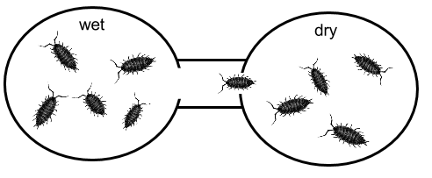

**Part B - Orientation of Isopods in Response to Moisture**

Procedure: Set up your behavior chamber so that you have one side moist and one side dry (using paper towels). Transfer 5 isopods to each side of the chamber (total of 10). Count and record the number of animals on each side of the chamber every 30 seconds for **ten minutes**, using a table like the one below.

**You will need to include this data in your lab report!**

|  |  |  |  |
| --- | --- | --- | --- |
| Time | # in Wet | # in Dry | Other Notes |
| 0:00 |  |  |  |
| 1:00 |  |  |  |
| 2:00 |  |  |  |
| 3:00 |  |  |  |
| 4:00 |  |  |  |
| 5:00 |  |  |  |
| 6:00 |  |  |  |
| 7:00 |  |  |  |
| 8:00 |  |  |  |
| 9:00 |  |  |  |
| 10:00 |  |  |  |

**Part C - Student Designed Experiment**

Select TWO of the following factors to investigate and design an experiment to test it. (Use the procedure above as a guideline.) You may also propose your own test, check with me.

Begin with a hypothesis, written as an IF-THEN statement. You will also need to include data on these experiment in your lab report, similar to the chart above.

|  |  |
| --- | --- |
| Factor | Possible Materials |
| Temperature | Cold pack, warm pack, ice, warm water |
| Light | Lamps, flashlights, dark construction paper, aluminum foil |
| pH | HCL, NaOH, vinegar, baking soda |
| Substrate (surface) | Soil, sand, bark, cedar, gravel |
| Odor | Ammonia, perfume, lemon juice |
| Food | Potato, fish flakes |
| Organisms | Crickets, earthworms, plants |

Analysis (include in lab report):

1. Did the isopods exhibit kinesis, taxis or an obvious preference to one environment over the other?
2. What advantage might this behavior have for the isopod?
3. How could the experiment be improved?

**Lab report should include:**

1. Drawing/sketch
2. Data from part B
3. Design, Data, and answers to analysis questions from Part C

|  |  |  |  |  |  |
| --- | --- | --- | --- | --- | --- |
|  | Excellent (4) | Good (3) | Adequate (2) | Needs Work (1) | No Attempt (0) |
| Background - purpose of experiment is clear |  |  |  |  |  |
| Data tables labeled and clear |  |  |  |  |  |
| Response to moisture question answered, supported |  |  |  |  |  |
| Student Designed - methods specific, appropriate use of the scientific method |  |  |  |  |  |
| Student Designed - summarizes data, draws conclusions, suggests improvements, reasoning sound |  |  |  |  |  |
| Format - no major grammar or spelling errors, typed, clear headings or sections, on-time |  |  |  |  |  |