AP Biology Name: __________________________
Chi Square Practice Problems Date: ___________________________
Chi-Square is a statistical tool that helps us to decide if the observed ratio is close enough to the expected ratio to be acceptable. Chi-square analysis can be used in any area, not just genetics. Whenever you have to determine if an expected ratio fits an observed ratio, you can use the Chi-square.
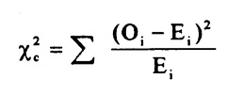
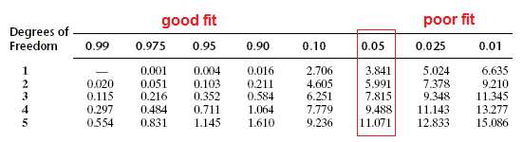
- In peas, yellow seeds (A) are dominant over green (a) seeds. In a cross between two plants both heterozygous for seed color, the following was observed:
Yellow = 4400 Green = 1624
Does the data fit the predicted phenotypic ratio?
Phenotype | Observed (O) | Expected (E) | O-E | (O-E)2 | (O-E)2/E
Totals

- In peas, smooth seeds ® are dominant over wrinkled seeds (r). In the P generation, a plant homozygous for smooth seeds is crossed with a plant with wrinkled seeds. The resulting F1 plants are crossed. The seeds of the observed F2 generation were:
Smooth= 5474 Wrinkled = 1850
Does the data fit the predicted phenotypic ratio?
Phenotype | Observed (O) | Expected (E) | O-E | (O-E)2 | (O-E)2/E
Totals
- In a flowering plant, white flowers (B) are dominant over red (b), and short plants (E) are dominant over tall (e) plants. When two double heterozygote (BbEe) plants were crossed, the resulting phenotypes were observed:
White, short = 206 White, tall = 65
Red, short = 83 Red, tall = 30
Does the data fit the predicted phenotypic ratio?
Phenotype | Observed (O) | Expected (E) | O-E | (O-E)2 | (O-E)2/E
Totals

- In corn, purple kernels (D) are dominant over yellow (d), and smooth kernels (G) are dominant over shrunken (g). An ear of corn has 381 kernels:
A: purple, smooth = 216
B: purple, shrunken = 79
C: yellow, smooth = 65
D: yellow, shrunken = 21
Does the data fit your predicted phenotypic ratio? (Your prediction would be the kernals are the result of a double heterozygous cross with a ratio of 9:3:3:1)
Phenotype | Observed (O) | Expected (E) | O-E | (O-E)2 | (O-E)2/E
Totals

- Color blindness is a sex-linked trait in Bobcats. A female who is a carrier of the color blind allele mates with a male who is color blind. The phenotypes of their offspring are:
Normal female = 132 Normal male = 126
Color blind female = 124 Color blind male = 136
Does the data fit your predicted phenotypic ratio?
Phenotype | Observed (O) | Expected (E) | O-E | (O-E)2 | (O-E)2/E
Totals

